A2+ LESSON 6 RCA 6 The Earth

**Warm-up: Likes, Dislikes, Favorites, and Preferences**

Are you good at sports?

What’s your favorite sport?

What’s your favorite weather?

What’s your favorite dessert?

What’s your favorite cuisine—for example, Chinese cuisine or Italian cuisine?

What food do you NOT like?

What sport do you NOT like?

Which do you prefer, tennis or football?

Do you enjoy eating going to the beach?

Do you eat meat?

Which do you prefer, mountains or beaches?

Would you like a cup of tea right now?

Do you know how to ride a bicycle?

Is chocolate cake fattening?

Do you like sweet foods?

Do you like Chinese food?

Do you take a shower in the morning?

Do you ever walk to work or school?

How often do you eat in restaurants?

Is tennis a kind of sport?

Which do you prefer, driving or riding a bus?

Are vegetables good for your health?

Is playing a sport good for your health?

Do you eat healthy food? Do you eat food that is sweet and fattening?

**Main Activity 1: Earth’s Atmosphere**

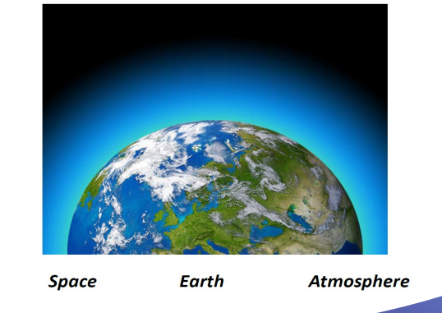

The Earth is **at the bottom** of the photograph.

The atmosphere is **just above** the Earth’s surface.

The atmosphere is **between** the Earth and space.

Space is **above** the atmosphere. Space is a **vacuum.** It has no air.

The atmosphere is **made up of** gases.

The atmosphere **contains** oxygen and nitrogen.

We breathe oxygen.

The atmosphere **makes** our sky blue.

Without an atmosphere, we **wouldn’t be able to** breathe.

Without an atmosphere, we **could not** live.

Without an atmosphere, life **could not** exist on Earth.

**Main Activity 2: Earth’s Land and Water**

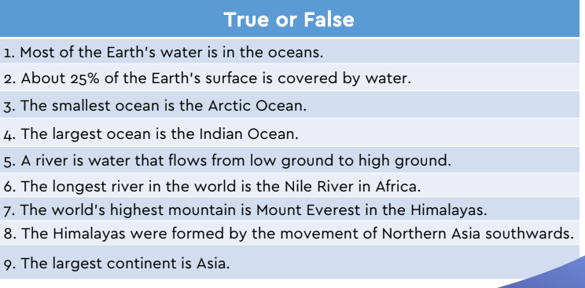

1. True

2. False. About 75% of the Earth’s surface is covered by water.

3. True

4. False. The largest ocean in the world is the Pacific Ocean.

5. False. A river is water that flows from high ground to low ground.

6. True

7. True

8. False. The Himalayas were formed by the movement of Southern Asia northwards.

9. True.

**Main Activity 3: Latitude and Longitude**

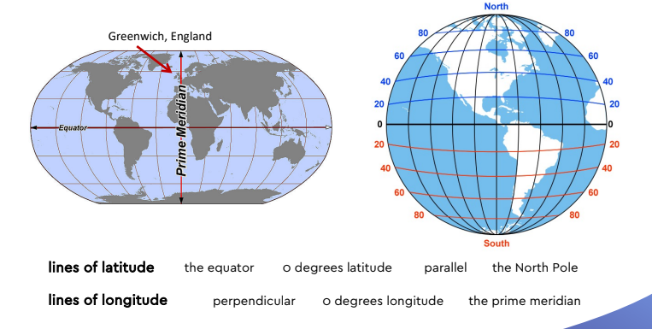

**Lines of latitude:** Lines of latitude circle the Earth from east to west. We measure them in degrees. They start at the equator, which is zero degrees latitude. All other lines of latitude are parallel to the equator and are measured from the equator. Lines of latitude are either north or south. The North Pole and the South Pole are the farthest latitudes from the equator. The North Pole is 90 degrees north; the South Pole is 90 degrees south.

**Lines of longitude:** Lines of longitude circle the Earth from north to south. They are perpendicular to the equator. The lines start at the prime meridian, which runs through the city of Greenwich, England. The prime meridian is zero degrees longitude. Lines of longitude tell you how far east or west of the prime meridian a place is.

